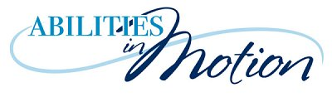
www.abilitiesinmotion.ca

Phone: 705 435-9123 info@abilitiesinmotion.ca

Regatta Registration Form

Course: AIM’s Regatta Date: Day 22/23 Month July Year 2022

Name: (Please print clearly)

Email: (Please print clearly) Tel

Events: Please indicate, in numerical order, your top four choices of events you wish to enter.

Parade of Colours: Each boat is affixed with a flag/streamer & paddles in a parade.
Scavenger Hunt: Each participating team seeks posters placed around the shoreline, takes a photo or prints the letter on a record sheet. Upon returning to the shore, the team creates a story using the photos, or, uses the letters to create as many words as possible (like anagrams)
Big Canoe Project: In groups of up to 14 paddlers, take a 30 minute tour of the reservoir.
Check of your choice of time below, please.
9:00 – 9:45 9:45 – 10:30 10:30 – 11:15 11:15 – 12:00
Sprint Races: Participating paddlers race between markers about 200 m apart.
Slalom Races: Participating paddlers navigate their boat through a slalom course about 200 metres.
Demonstration of Skills: Each boat (one or two paddlers) creates and demonstrates a short routine of at least five paddling skills
Tug-of-War: Two catamaran canoes, with 3-4 paddlers, are secured together and paddle in opposite directions until they have reached their respective finish line (about 5 metres).
Throw Bag Challenge: Onshore, participants are challenged to toss a throw rope the greatest number of times such that it lands in a one metre circle.

Please Email this form to: creekpaddler4@gmail.com, by July 15.

